In Lab Statement 1

a)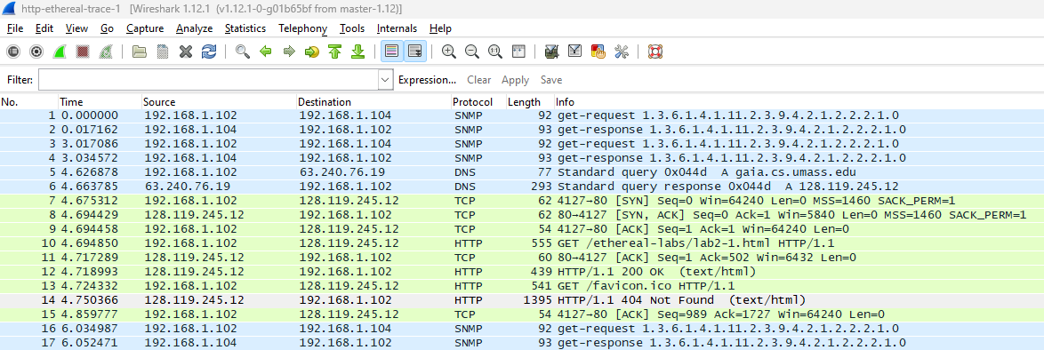

b)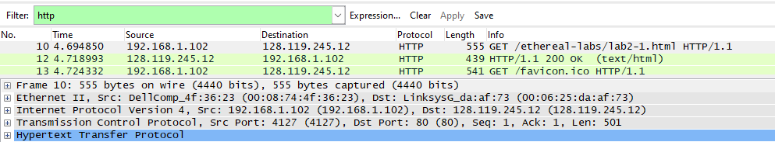

c)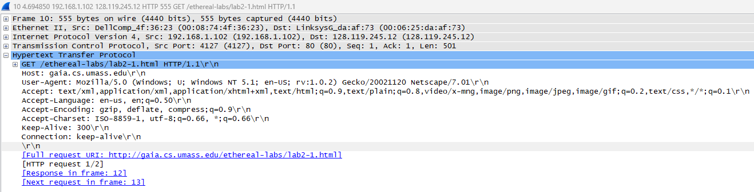

d)

1- List up to 4 different protocols that appear in the protocol column in

the unfiltered packet-listing window.

Ans: TCP, HTTP, SNMP, DNS

2- How long did it take from when the HTTP GET message was sent until

the HTTP OK reply was received?

Ans: 4.718993 - 4.694850 = 0.024143



3- Was the second Get Request successful? How can you tell it from the

corresponding response packet?

Ans: It was not successful because the reply shows Error code of page not being found.



4. Is your browser running HTTP version 1.0 or 1.1? What version of

HTTP is the server running?

Ans: Version 1.1

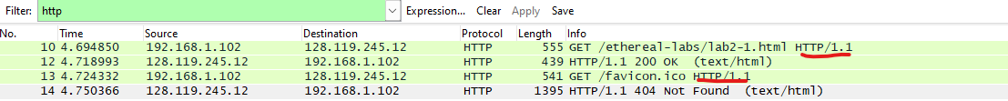

5. What languages (if any) does your browser indicate that it can accept

to the server?

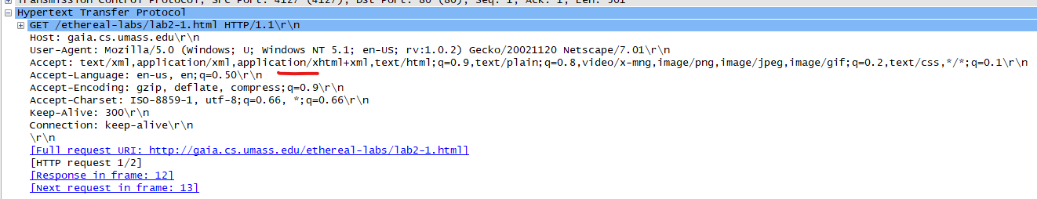

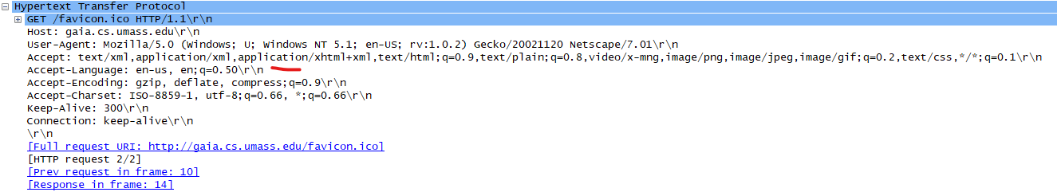

Ans: en-us and en

6. What is the IP address of the gaia.cs.umass.edu server and your

Computer?

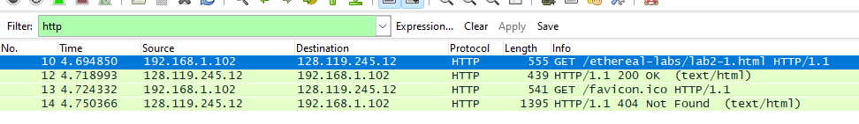

Computer IP’s address: 192.168.1.102

gaia.cs.umass.edu server’s IP address: 128.119.245.12

7. What is the MAC address of the server and your computer?

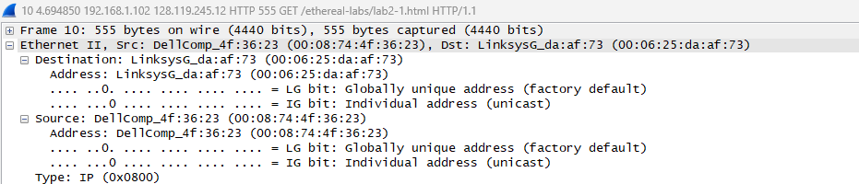

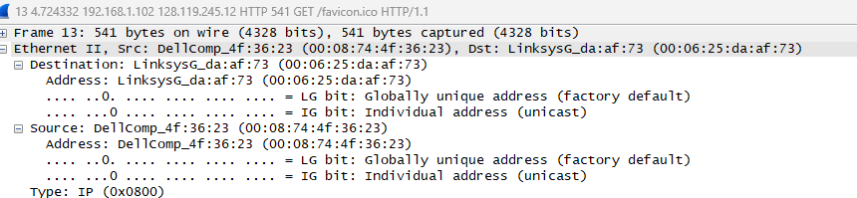

8. What is sending and receiving Port Number? What does Port No. 80

represents?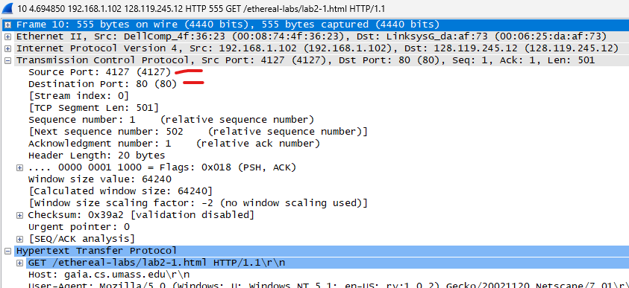

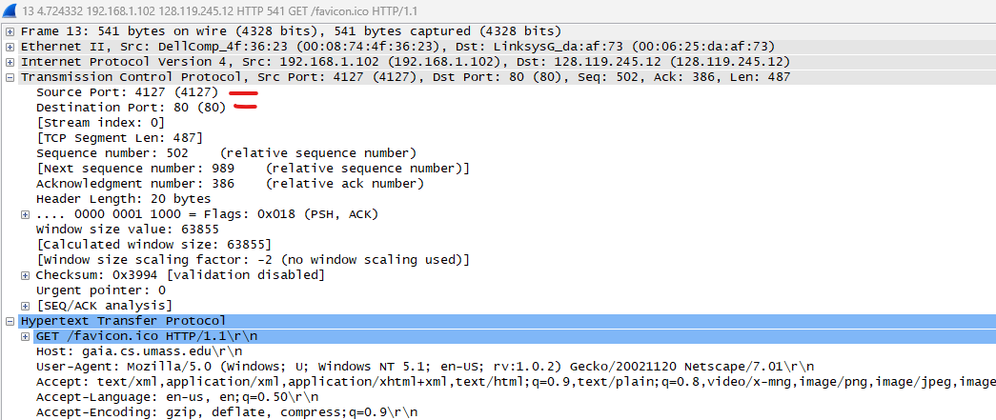

Ans: Sending Port Number: 4127

Receiving Port Number: 80

9. What is the status code returned from the server to your browser?



Request 1 status code: 200

Request 2 status code: 404

10. When was the HTML file, that you are retrieving, last modified at

the server?

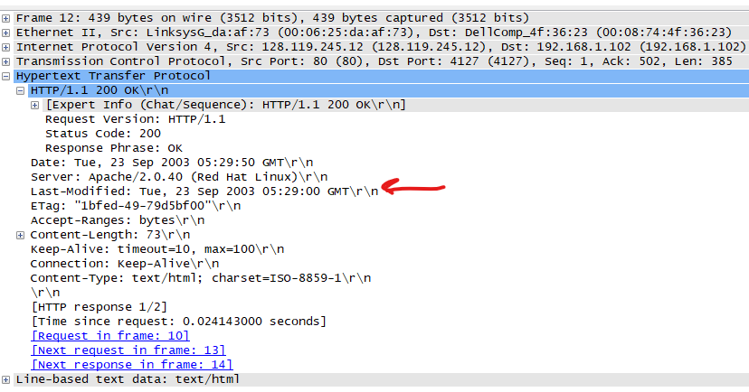

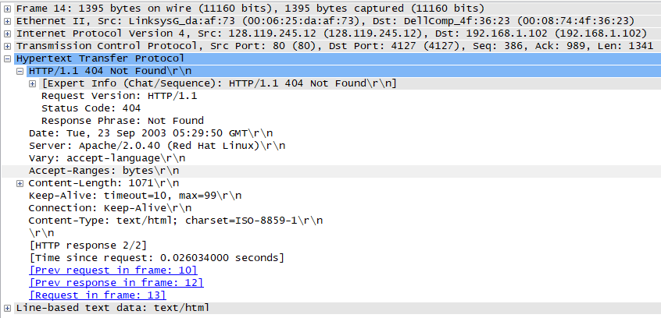

Ans: First HTML file was last modified at Tuesday, 23rd September 2003 at 5:29:50 GMT.

Second HTML file’s last modification date is not available as the page wasn’t returned.

11.How many bytes of total packet content are being returned to your

browser?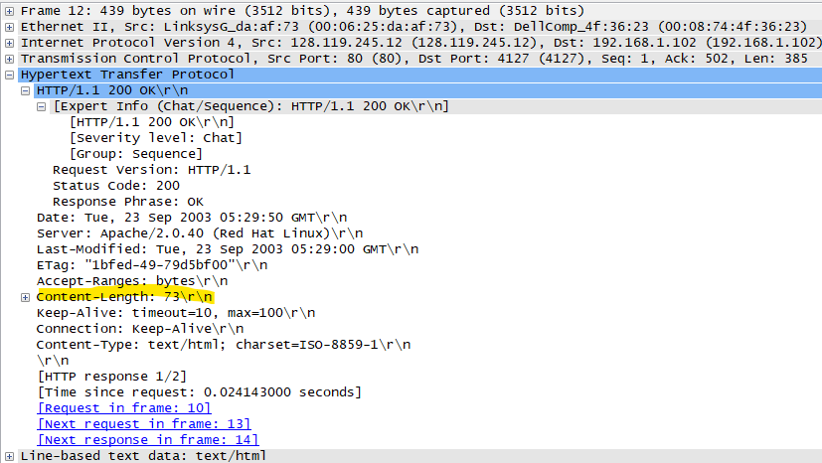

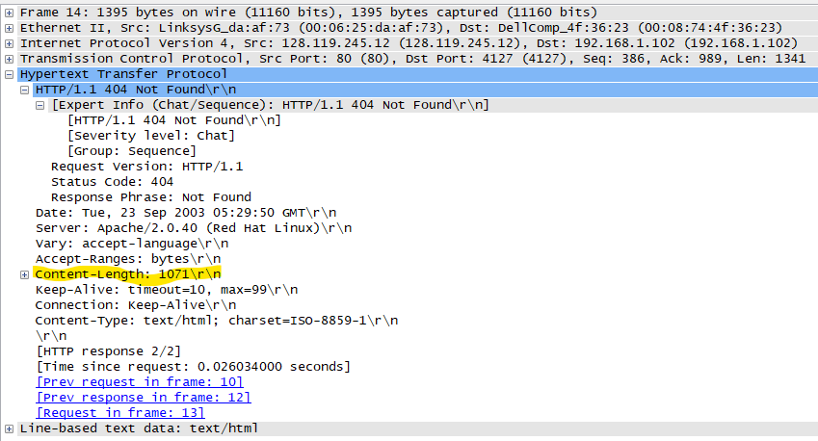

Bytes from first file: 73

Bytes from second file: 1071

Ans: Total = 73 + 1071 = 1144 bytes

The HTTP CONDITIONAL GET/response interaction

Using the http-ethereal-trace-2 packet trace.

1. Inspect the contents of the first HTTP GET request from your browser to

the server. Do you see an “IF-MODIFIED-SINCE” line in the HTTP GET?

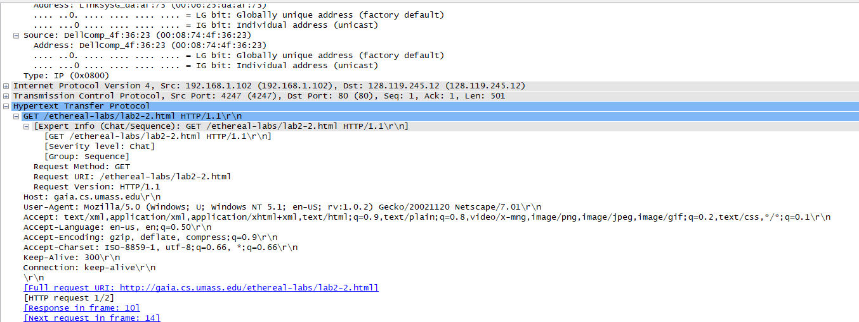

Ans: No.

2. Inspect the contents of the server response. Did the server explicitly return

the contents of the file? How can you tell from the Packet Bytes Window?

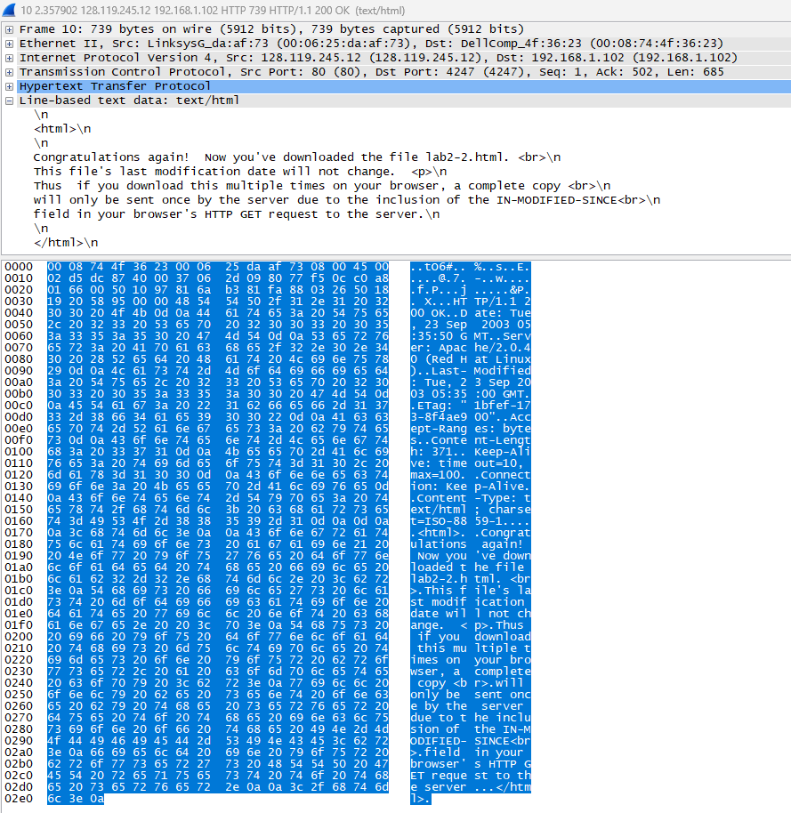

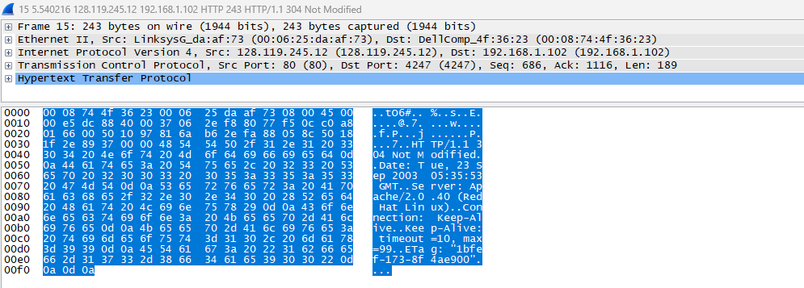

Ans: Yes. This is because every packet byte corresponds to some data in every protocol.

3. Now inspect the contents of the second HTTP GET request from your

browser to the server. Do you see an “IF-MODIFIED-SINCE:” line in the

HTTP GET? If so, what information follows the “IF-MODIFIED-SINCE:”

header? What is meant by this information?

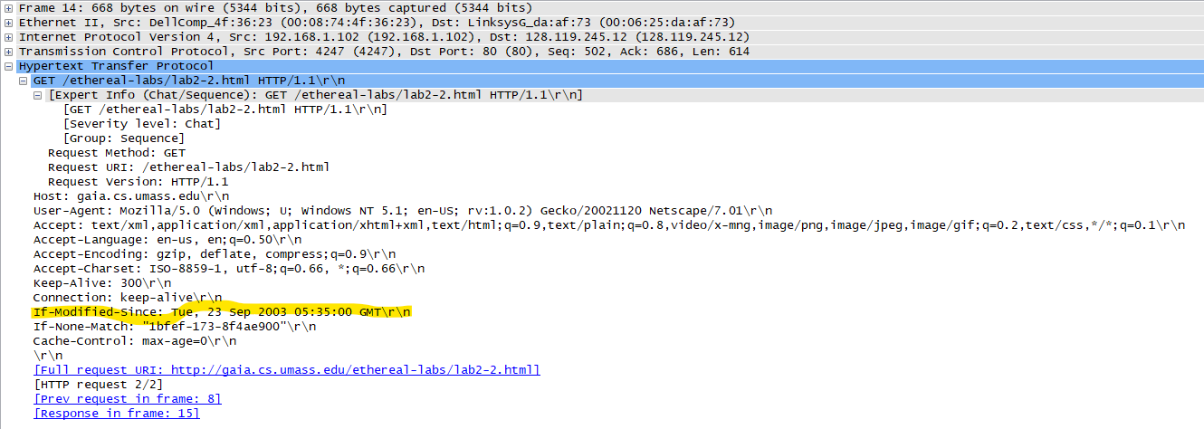

4. What is the HTTP status code and phrase returned from the server in

response to this second HTTP GET? Did the server explicitly return the

contents of the file? Explain your answer.

Ans:Status Code: 304

It didn’t explicitly return the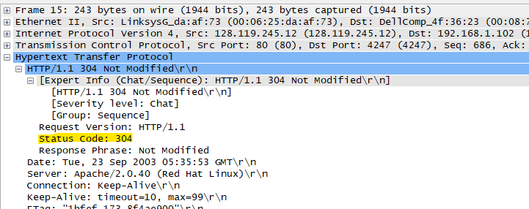 contents of the file because a redirection message was returned.

In-Lab Statement 2 : Analyzing HTTP Protocol

5. How many HTTP GET request messages did your browser send?

Ans: 1



6. Which packet number in the trace contains the GET message for The Bill

of Rights?

Ans: Packet 10.

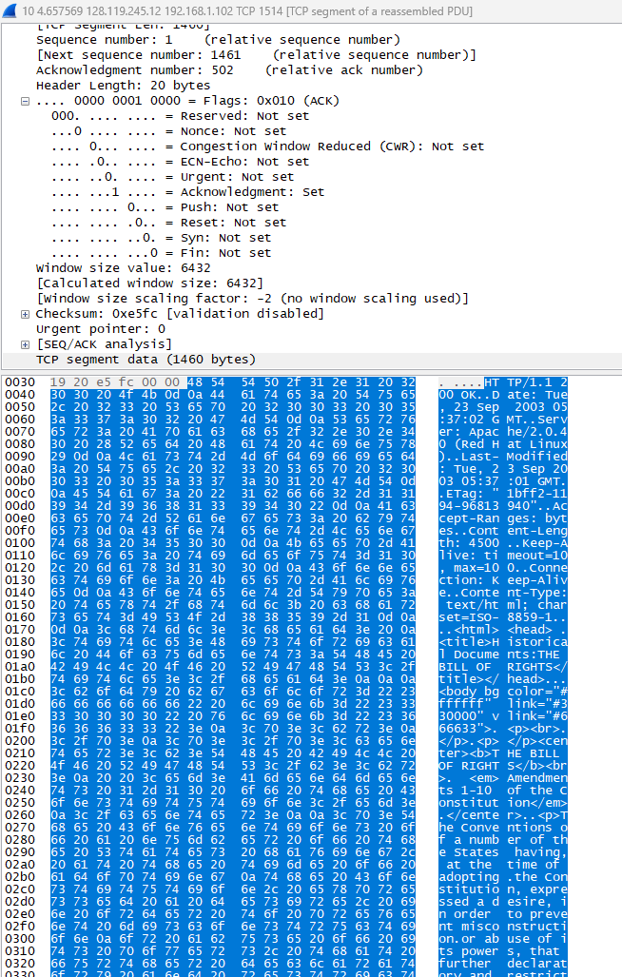

7. Which packet number in the trace contains the status code and phrase

associated with the response to the HTTP GET request?

Ans: Packet 14

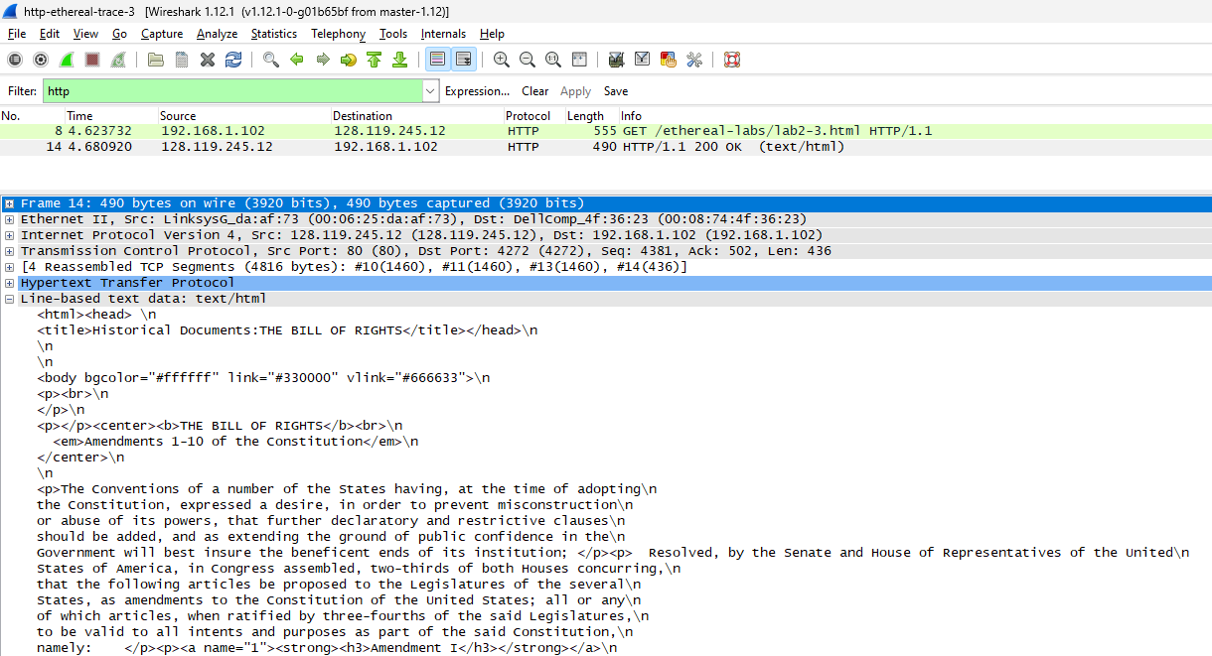

8. What is the status code and phrase in the response?

Status Code: 200

Phrase: OK



9. How many data-containing TCP segments were needed to carry the single

HTTP response and the text of the Bill of Rights? What are the numbers of

those packets?

TCP segments: 3

3 packets

In-Lab Statement 3: Trick Question

What is the length of the text for The Bill of Rights in bytes? How do

you justify this length of text when your Response Packet Size is only

490 bytes? Give complete explanation how the length of text in various

packets add up to a total of 4500 Bytes.

Ans:

Every TCP segment has a length of 1514 bytes out of which 14 bytes are of reassembled PDU.

Hence, total length is 3\*(1514) *- 3\**(14) = 4500 bytes.